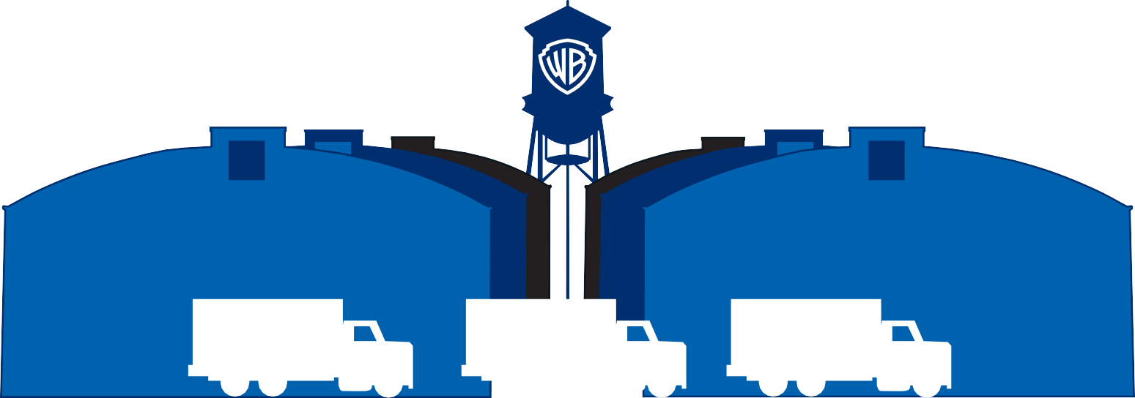

**100 FREE MILES PER DAY,**

**700 PER WEEK**

**EXCESS MILES BILLED AT 25¢ PER MILE**



TRANSPORTATION EQUIPMENT RATES

|  |  |  |
| --- | --- | --- |
| **EQUIPMENT** | **DAILY RATE** | **WEEKLY RATE (7 Days)** |
| Explorer / F150 | $120.00 | $600.00 |
| 15-Passenger Transit Van | $160.00 | $800.00 |
| 35-Passenger Shuttle Bus $520.00 $2,600.00 | | |
| Crew Cab F350 | $145.00 | $725.00 |
| C/C Stakebed F550 (10’) | $160.00 | $800.00 |
| C/C Stakebed F550 (12’) | $165.00 | $825.00 |
| Crew Cab F550 Cube Truck | $170.00 | $850.00 |
| HD C/C Stakebed F650 (12’ or 14’) | $175.00 | $875.00 |
| HD Fuel Truck 5th Wheel | $185.00 | $925.00 |
| HD C/C Stakebed 5th Wheel (12’ or 14’) | $175.00 | $875.00 |
| HD Extended Cab 5th Wheel Stakebed (12’) | $175.00 | $875.00 |
| Shorty 40 | $190.00 | $950.00 |
| 5-Ton C/C Box | $180.00 | $900.00 |
| 5-Ton C/C Stakebed | $180.00 | $900.00 |
| 7-Ton C/C Air Ride | $185.00 | $925.00 |
| 10-Ton Peterbilt XL Van (29.6’) | $255.00 | $1,275.00 |
| 10-Ton Crew Cab (25.9’) | $270.00 | $1,350.00 |
| 2-Axle Peterbilt Tractor | $180.00 | $900.00 |
| 3-Axle Peterbilt Tractor | $195.00 | $975.00 |
| Single Car Trailer | $100.00 | $500.00 |
| 3-Car Trailer | $150.00 | $750.00 |
| Forklift Under 6,000 lbs. | $120.00 | $600.00 |
| Forklift Over 6,000 lbs. | $150.00 | $750.00 |

Prices effective July 2025 Prices subject to change without notice.